For NUnit Testing , we need two packages

**NUnit, NUnit3 Test Adapater**

**NUnit** is a unit-**testing framework**

The **NUnit Test Adapter** allows you to run **NUnit tests** inside Visual Studio. If you do not add this component in your project you will not be able to find your **tests** in **test** Explorer. You need to install both the Libraries in the project where you are writing the **test** methods only.

Code Coverage : That our test cases are enough or not

using NUnit.Framework;

using System;

using System.Collections.Generic;

using System.Linq;

using System.Text;

using System.Threading.Tasks;

namespace NUnitTestingDemo.Tests

{

[TestFixture]

public class NumericFunctionsTestClass

{

[Test]

public void addTest()

{

// Arrange

NUnitTestingDemo.NumericFunctions obj = new NUnitTestingDemo.NumericFunctions();

// Act

int res = obj.add(10, 30);

// Assert

Assert.AreEqual(40, res);

}

}

}

using NUnit.Framework;

using System;

using System.Collections.Generic;

using System.Linq;

using System.Text;

using System.Threading.Tasks;

namespace NUnitTestingDemo.Tests

{

[TestFixture]

public class NumericFunctionsTestClass

{

[Test]

public void addTestFor40()

{

// Arrange

NUnitTestingDemo.NumericFunctions obj = new NUnitTestingDemo.NumericFunctions();

// Act

int res = obj.add(10, 30);

// Assert

Assert.AreEqual(40, res);

}

[Test]

public void addTestFor60()

{

// Arrange

NUnitTestingDemo.NumericFunctions obj = new NUnitTestingDemo.NumericFunctions();

// Act

int res = obj.add(30, 30);

// Assert

Assert.AreEqual(60, res);

}

}

}

But anyone can write in a Test case

Assert(true,true) > It will always give you success , how to check that we have written enough test cases

using NUnit.Framework;

using System;

using System.Collections.Generic;

using System.Linq;

using System.Text;

using System.Threading.Tasks;

namespace NUnitTestingDemo.Tests

{

[TestFixture]

public class NumericFunctionsTestClass

{

[Test]

public void addTestFor40()

{

// Arrange

NUnitTestingDemo.NumericFunctions obj = new NUnitTestingDemo.NumericFunctions();

// Act

int res = obj.add(10, 30);

// Assert

Assert.AreEqual(40, res);

}

[Test]

public void addTestFor60()

{

// Arrange

NUnitTestingDemo.NumericFunctions obj = new NUnitTestingDemo.NumericFunctions();

// Act

int res = obj.add(30, 30);

// Assert

Assert.AreEqual(60, res);

}

[Test]

public void CheckForHR()

{

NUnitTestingDemo.NumericFunctions obj = new NumericFunctions();

Assert.AreEqual(20,obj.GetLeaves("HR"));

}

}

}

How to provide multiple values & expected output together to the test case

[TestCase(10,20, 30)]

[TestCase(40, 20, 60)]

[TestCase(60, 20, 80)]

[TestCase(20, 20, 30)]

[TestCase(20, 20, 40)]

public void addTest(int x, int y, int expectedOutput)

{

// Arrange

NUnitTestingDemo.NumericFunctions obj = new NUnitTestingDemo.NumericFunctions();

// Act

int res= expectedOutput = obj.add(x, y);

// Assert

Assert.AreEqual(res, expectedOutput);

}

Code Coverage is an Enterprise Edition feature, not available in Professional.

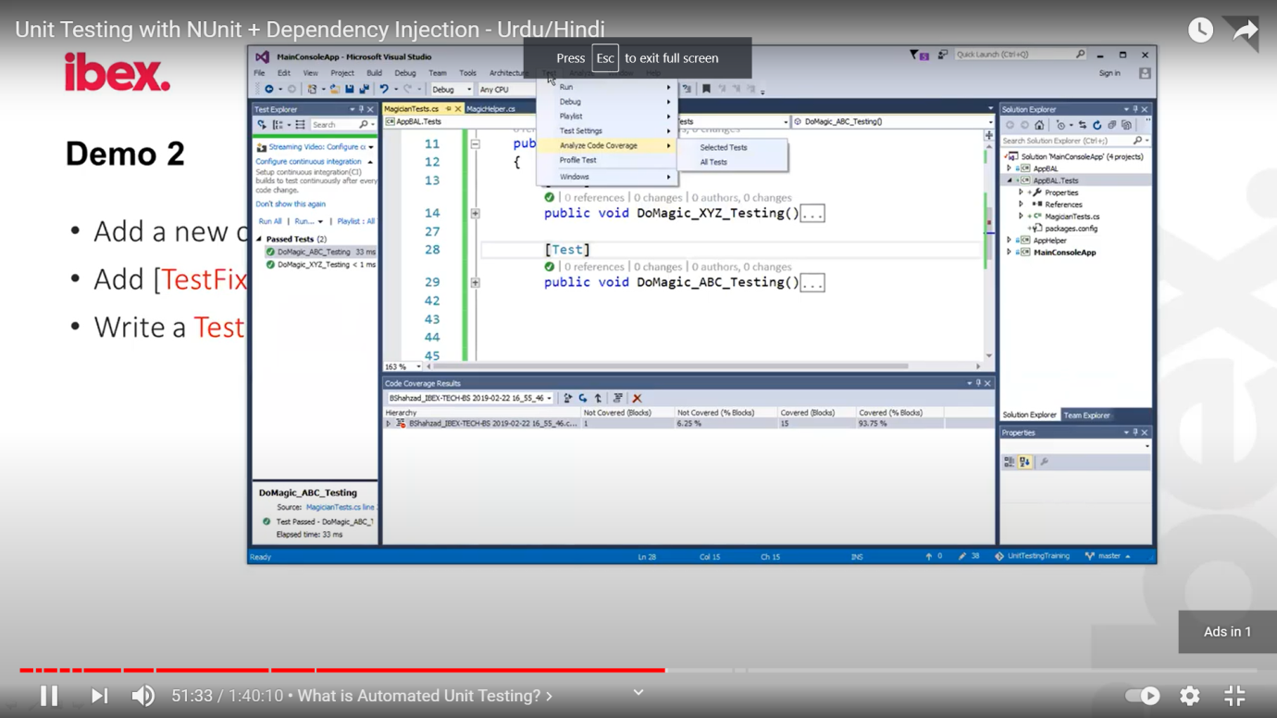

Testing a method that calls some other method that might be accessing database or something else

How to test that

public int CallingSomeotherMethod(int value)

{

SecondClass obj = new SecondClass();

int x = obj.ThisMethodWillBeCalled(value);

if (x > 10) return 10;

else return 100;

}

class SecondClass

{

public int ThisMethodWillBeCalled(int x)

{

x = x + 10;

return x;

}

}

Here we need to test CallingSomeotherMethod() , but it is dependent on some method. What shall we do? There is tight coupling here.

**What shall we do: Free your test methods from all such external dependencies**

<https://www.webtrainingroom.com/csharp/unit-testing>

using System;

using System.Collections.Generic;

using System.Linq;

using System.Text;

using System.Threading.Tasks;

namespace TestProject

{

public class Customer

{

public bool AddCustomer()

{

EMailClass obj = new EMailClass();

obj.sendMail();

// Some code of ADO.Net will go here

return true;

}

}

}

We want to bypass the first two lines

First Change in Customer Class

using System;

using System.Collections.Generic;

using System.Linq;

using System.Text;

using System.Threading.Tasks;

namespace TestProject

{

public class Customer

{

public virtual bool AddCustomer(EMailClass obj)

{

//EMailClass obj = new EMailClass();

obj.sendMail();

// Some code of ADO.Net will go here

return true;

}

}

}

[Test]

public void AddCistomerTest()

{

Mock<TestProject.EMailClass> obj = new Mock<TestProject.EMailClass>();

//create the object

// which function to by pass

Mock<TestProject.EMailClass> obj = new Mock<TestProject.EMailClass>();

// Setup the moq

obj.Setup(x => x.sendMail()).Returns(true);

TestProject.Customer customer = new TestProject.Customer();

bool isInserted = customer.AddCustomer(obj.Object);

Assert.AreEqual(isInserted, true);

}

The **moq** use [dynamic proxy](http://www.castleproject.org/projects/dynamicproxy/) to create wrapper around mocked type in order to be able to intercept calls and change the behaviour of the invoked methods.

How proxy is built?

* If you mocking interface proxy is just an implementation of the interface
* If you have class the proxy is override of the class

